### Chrome Extension Development Assignment 3

**Objective:** Develop a Chrome extension that performs specific actions on the given eBay pages. The extension must adhere to the outlined requirements and exceptions to ensure functionality is both targeted and controlled.

#### ****Page 1****: [eBay Explore Page](https://www.ebay.com/explor)

1. **Trigger:** The extension should execute at the **end of the page load**.
2. **Actions:**
   * **Blur Images:** Blur the product images of the **first 4 products** displayed on the page.
   * **Change Price Color:** For the **next 4 products**, change the price color to **red**.
   * **Hide Products:** For all subsequent products(except first 8), hide them **if their price is greater than $100**.

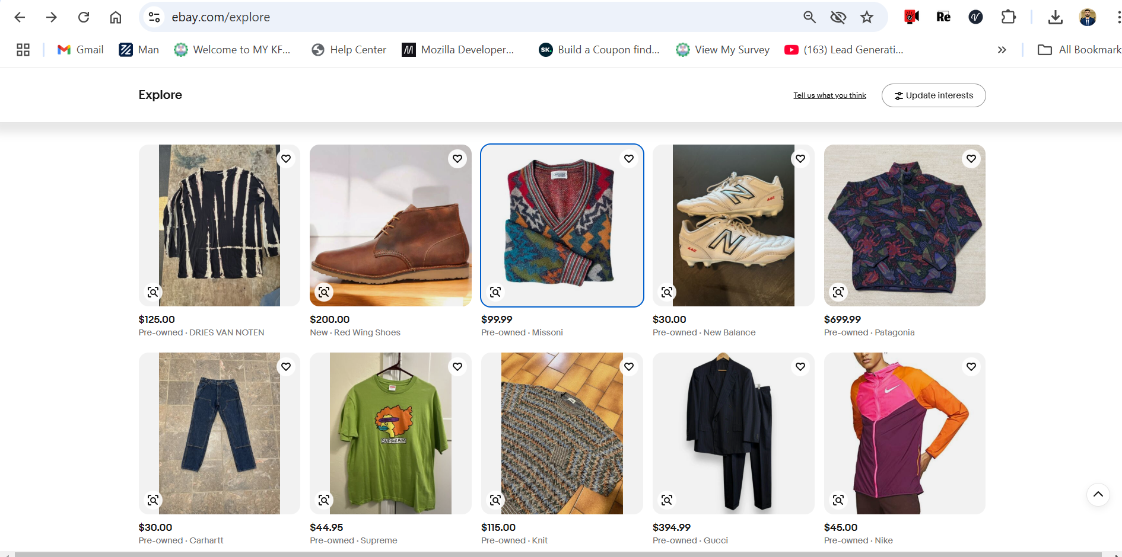

#### ****Page 2****: [eBay Product Page](https://www.ebay.com/itm/186850120579)

1. **Pattern Matching:** Match the displayed product price (numbers will vary dynamically).
2. **Add $100:**
   * Calculate a new price by adding **$100** to the original product price.
   * Display the updated price directly **below the original price** on the product page.
   * Use a **green color** to style the new price for clear visibility.
   * Display the new price after addition of **$100** in extension badge(if the new prices is less then $150 then badge color should be green if it’s greater than $150 then badge color should be red) Tip: send this updated price as a message to service-worker then set badge text and color

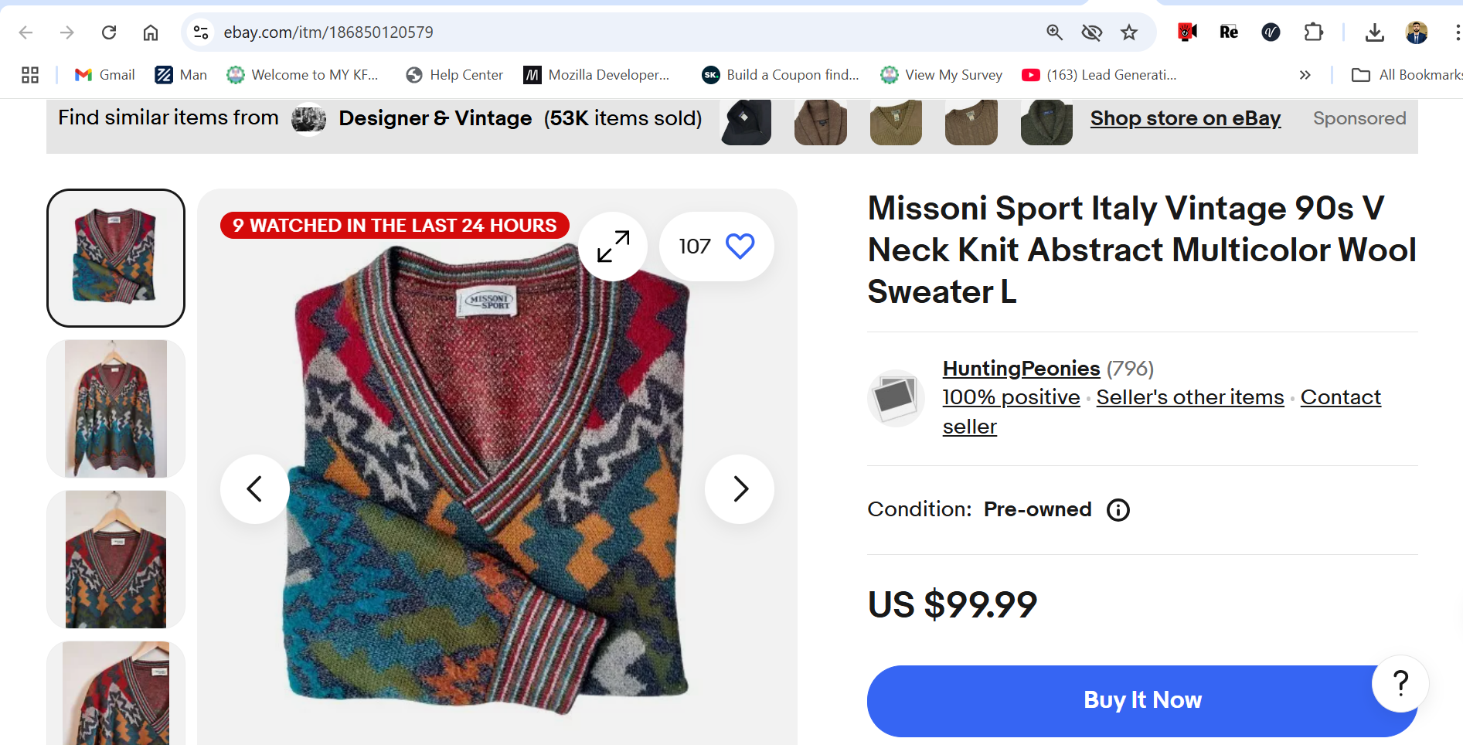

#### ****Exclusions:****

1. The extension **must not** run on the following URLs:
   * [Video Games & Consoles](https://www.ebay.com/b/Video-Games-Consoles/1249/bn_1850232)
   * [Other Vehicles & Trailers](https://www.ebay.com/b/Other-Vehicles-Trailers/6038/bn_1865426)
   * [Account Settings](https://accountsettings.ebay.com/uas)
2. The extension should also be disabled if the URL **contains any of the following words**:
   * **"Boats"**
   * **"Cars-Trucks"**
3. **For all other pages under** [https://www.ebay.com/*](https://www.ebay.com/*) **it should console.log it’s current location url onload page**

### Additional Notes:

* Ensure the logic is efficiently implemented using **content scripts**.
* Style changes (e.g., colors, visibility) should be applied using **CSS file in content_scripts**
* Test the extension thoroughly to ensure it meets all specified conditions and does not interfere with other pages or features.